1. Description
TEMPer2 thermometer is a measurement device using USB port to connect to a computer. It has two sensors, one is inside and another is extended outside by a cable. The two sensors can test temperature at a same time and the outer sensor is protected from water. It can measure the temperature of the machine and the environment accurately. It must be connect to the computer to start working. TEMPer2 can be use in computer room, weather, environment and special environment temperature testing.
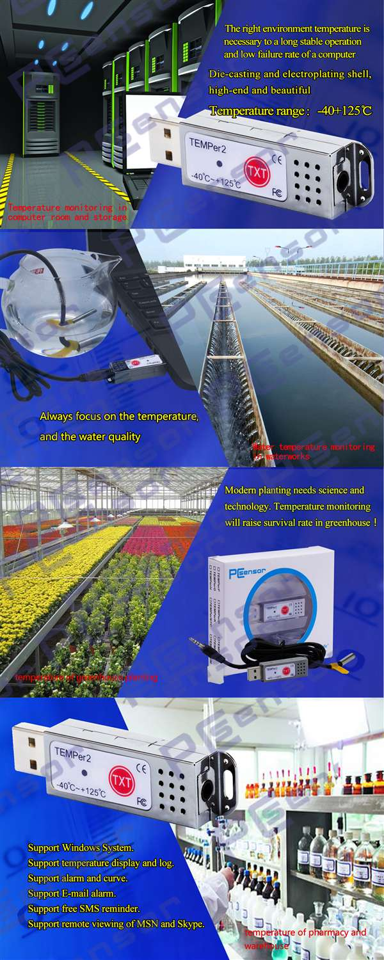
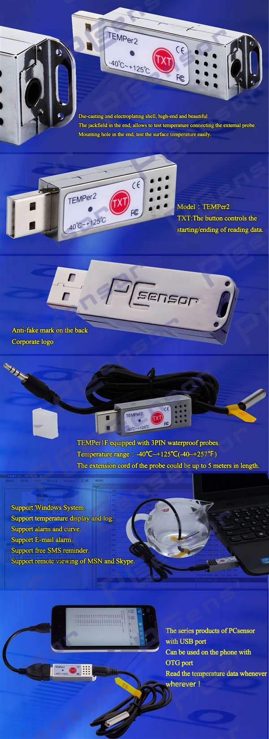
2. Packing specification
(NOTICE: In order to reduce the volume of goods and reduce the freight, and sometimes we will get rid of plastic packaging products)
Name of the part | Specification | Quantity
TEMPer2 | 50*17.5*7.2mm; 22g | 1
Driver CD | 3.5inch | 1
Sensor | cable length : 1m | 1
Product VerificationCertificate | - | 1

3. Function & Feature
l Range of measuring: TEMPer2 -40~+125 C; -40~+257F;
l Resolution rate: 0.06C
l Precision: + 2C;
l Electricity:< 5mA;
l Support Windows NT,XP, VIST;
l Memory requirement: 20M
l Data auto save to be txt Or csv form, can be open by excel;
l Send mails function
l Graph transfer function
New Function

TXT Special button:
As long as you long pressing the TXT button for 1 seconds, you can read the temperature no matter in excel, text or word form without running software. If to stop the reading, press the TXT button again . Easy operation! Solve your installed software and cross-platform used troubles!
Caps lock and Num Lock:
You don’t want to install software, OK! You can use the Caps lock and Num lock function.
As long as you long press the caps lock or num lock for 3 seconds, you can read the temperature no matter in excel, text or word form without running software. Then you can create curve.
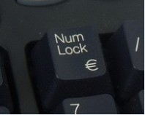
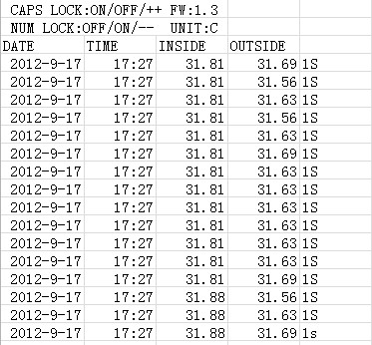
4. Installing instruction (Note: Our software only support windows system .)
Software installing instruction: please go to our website to download the process
a) Don't need to the USB driver
b) Install dotnetfx.exe, if your computer system is Vista, may be you don’t need to install this process. Dotnetfx.exe is framework 2.0 of Microsoft, you can download it from the website of Microsoft;
c) Decompress TEMPer.rar to you computer, and running TEMPer2.exe.
Hardware installing:
Plug the thermometer into the USB port of the computer to connect it and running the TEMPer2.exe.
5. Operating instruction
1) LOG
Record the Real-time Temperature Data and Save Them in the Related File Automatically. (see picture4)
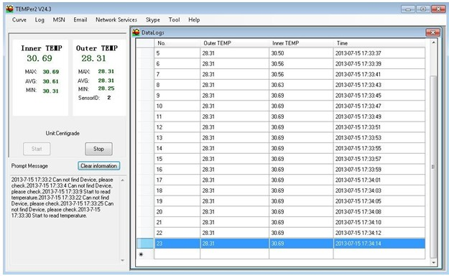
Picture 4 LOG
2) CURVES DISPLAY

There is Two Curves, One is AVG Line and the Other is Current Line. The User can Check the Situation of Temperature Contrastively. The Curves can Real-time Display the Changing Situation of Temperature. The Tendency of Curves Responds the Real-time Temperature Situation. (see picture3)
ADVISE: Please Check the Log or Data File in Save Contents When You Want to Check the Historical Data.
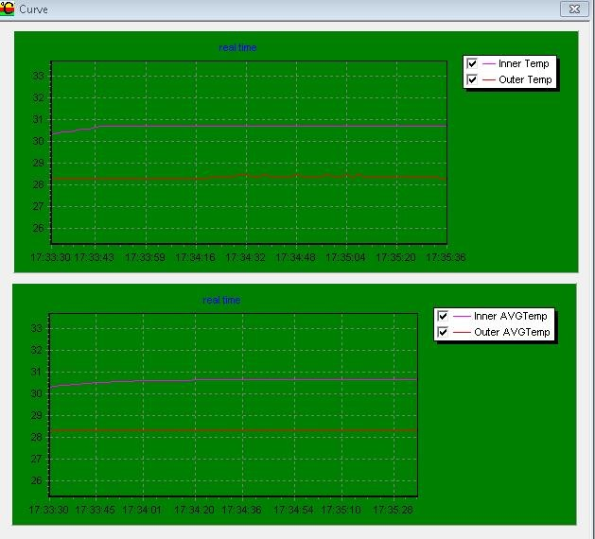
Picture 5 Curve
3) MSN FUNCTION
After the MSN User Log in, His Friends can Operate by Related Tips and Obtain the Temperature Data. Your Friends can obtain the Temperature Data Automatically When He Send “1”in According with Tips. The Temperature Data Including: Real-time Temperature, Maximum Value, Minimum Value and Average Value. (see picture 5)
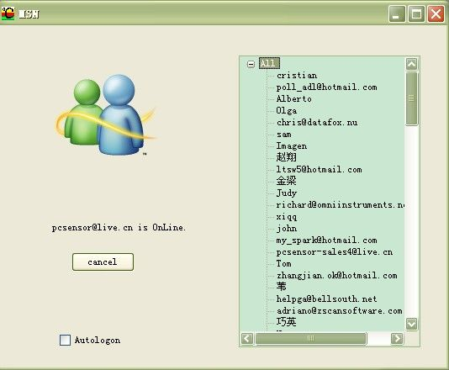
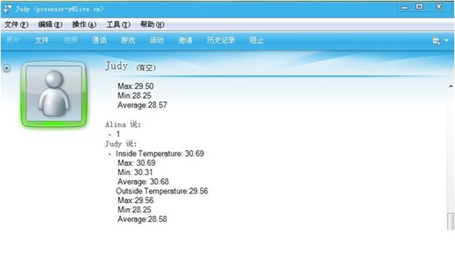
Picture 6 MSN
5) EMAIL FUNCTION

Fill in the Related Information of Email and Save it. The Requirement of Send Email: Support POP3/SMTP and Other Server Port. Receive Email you can fill in two.
Related Function: 1) when the Alarm is on, it will send the Email to Specified Email Box Automatically if the Temperature Reach the Alarm Limit. 2) You can set the Sending Interval, and then it will send the Email to the Specified Mail Box at Set Intervals. (Advise) 3) it can Send Email Continuously to the Specified Mail Box. (Deprecated feature) (See picture 7)
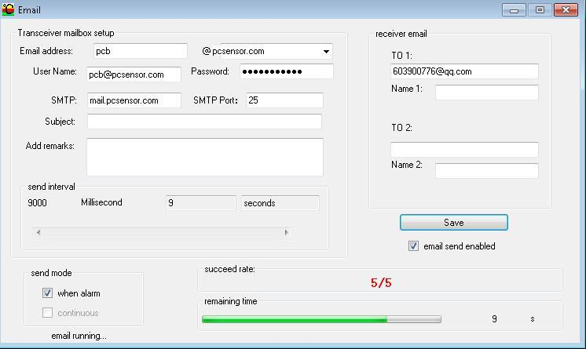
Picture 7 Email
6) THE SAVING SETTING OF FILE
Select “Tool->Option->Memory Setting” then you can Set the Saving File Catalog, File Type and the Maximum Record
Count the File can Save. (see picture8)
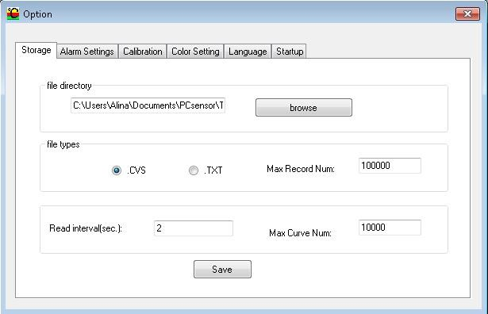
7) THE ALARM SETTING
Set the Temperature of Alarm and Open it. When the Temperature Reach the Higher Limit, the Voice of Alarm will Play, and it will Stop when the Temperature Drop to the Lower Limit.
Select “Toll->Select->Alarm” (see picture 9)
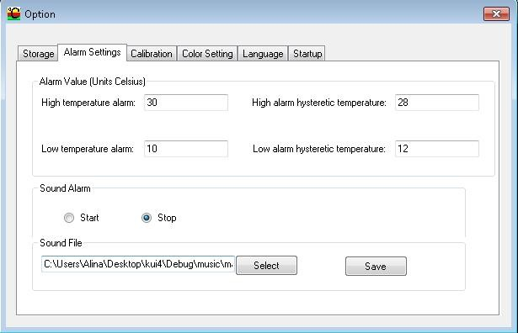
See picture 9

8) TEMPERATURE CORRECTION and UNIT SELECTION
When a Small Deviation occurs between the Displaying Temperature and the Actual Temperature, you can correct it through this Function. And you can select the unit of the temperature. (See picture 10)
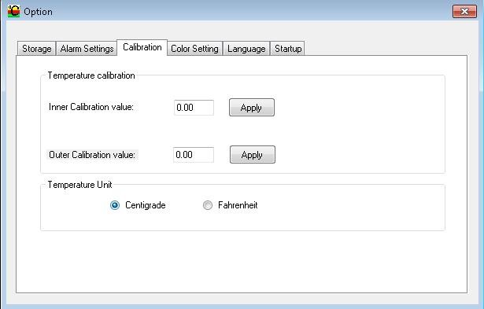
See picture 10

9) CHANGE THE COLOR OF BACKGROUD
Select “Tool->Select->Color Setting”, Click Color Frame or Button to Choose the Color you Like (see picture 11)
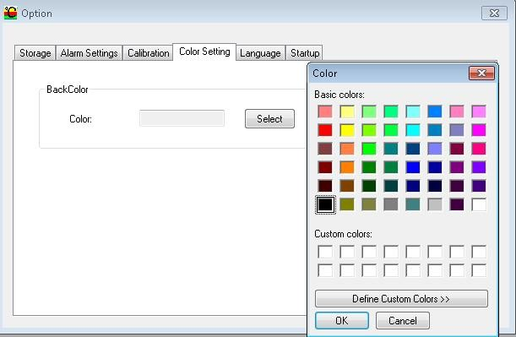
See picture 11

10) CHANGE LANGUAGE
Select “Tool->Select->Language, then Choose English or Chinese” (see picture 12)
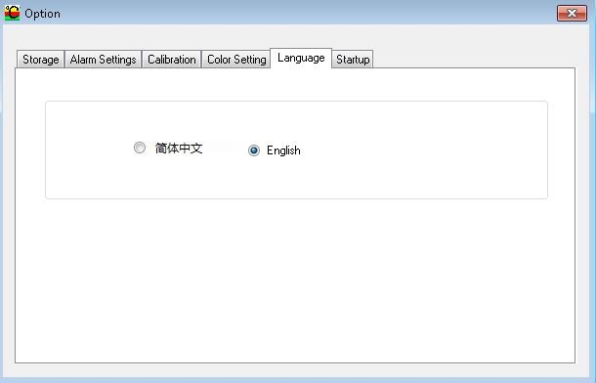
see picture 12
11) STARTUP
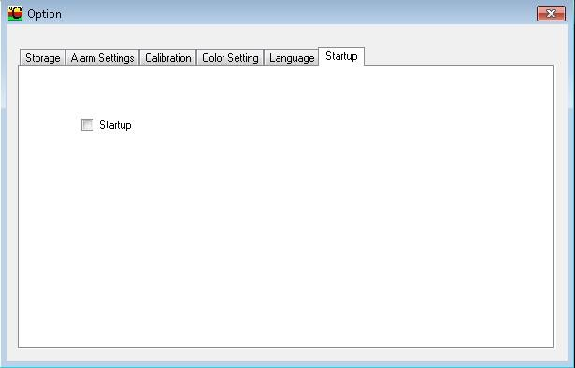
see picture 13
11) ABOUT
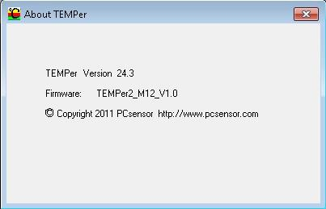
see picture 14

